*LOYOLA ICAM COLLEGE OF ENGINEERING AND TECHNOLOGY*

**SOFTWARE**

**REQUIREMENTS**

**SPECIFICATION**

**For**

**News Media application**

**Prepared by:-**

*KAVIENA SHARON C T*

*NADHEEDHA S*

*PRAVEENA B V*

*AHATHIYA S*

**Academic Year:** *2023-2024*

*Department of Information Technology*

**1. Introduction**

**1.1 Purpose of the project**

The News Media Application project aims to provide an extensive and user-friendly web application that offers its customers a seamless and interesting news consumption experience. The app seeks to serve a large audience that is interested in staying up to date on current affairs, breaking news, and a variety of topics from reliable sources.

**1.2 Document Conventions**

Entire document should be justified.

* Convention for Main title
* Font face: Times New Roman
* Font style: Bold
* Font Size: 14
* Convention for Sub title
* Font face: Times New Roman
* Font style: Bold
* Font Size: 12
* Convention for body
* Font face: Times New Roman
* Font Size: 12

**1.3 Scope of Development Project**

The creation of a news media application is a significant undertaking that involves several important factors. This project seeks to develop a cross-platform application that is user-friendly and delivers timely and customized news material. The choice of technological stacks, content management systems, and user authentication procedures falls under the purview of the scope. Design considerations center on producing a user interface that is responsive across a variety of devices that is both intuitive and aesthetically pleasing.

The integration of APIs will be necessary for content delivery in order to retrieve news articles, videos, and photographs from reputable sources using caching technologies for faster load times. According on user preferences, personalization algorithms will suggest material, and push notifications will inform users of breaking news. Additionally, tools like social sharing, comments, and subscriptions will be incorporated as monetization strategies.

Push alerts will inform users of breaking news, while personalization algorithms will suggest material based on user preferences. To increase engagement, monetization techniques like advertising or subscriptions will be used along with tools like social sharing, comments, and bookmarks. Priority one should be given to security and adherence to data privacy laws. Key factors will also include accessibility, localization, analytics, and performance optimization. This project's ongoing upkeep, updates, and user assistance channels are essential components. The scope is finished off with a clear budget and schedule, a marketing plan, and adherence to app store regulations. The success of this project depends on a carefully thought-out and carried-out development approach that gives user experience, content quality, and security first priority.

**1.4 Definitions, Acronyms and Abbreviations:**

Definitions:

**News Media Application:** A digital platform designed to aggregate, curate, and deliver news content to users through various media formats such as articles, videos, and multimedia.

**User:** An individual who accesses and interacts with the news media application, including readers, contributors, and administrators.

**Article:** A written news story or report containing text, images, and multimedia elements, providing information on a particular topic.

**Content Moderation:** The process of reviewing and approving or disapproving user-generated content to ensure compliance with platform guidelines and prevent the spread of false or harmful information.

**Fact-Checking:** The process of verifying the accuracy and credibility of news content to ensure that it is truthful and reliable.

**Two-Factor Authentication (2FA):** An additional layer of security that requires users to provide two separate forms of identification before gaining access to their accounts.

**Content Filtering:** The automated or manual process of screening and categorizing news content based on topics, tags, and keywords.

**Push Notification:** A brief message or alert sent to users' devices to inform them of breaking news, updates, or important events.

**Acronyms and Abbreviations:**

SRS: Software Requirement Specification

API: Application Programming Interface

CDN: Content Delivery Network

CMS: Content Management System

SSL/TLS: Secure Sockets Layer/Transport Layer Security

SQL: Structured Query Language

HTML: Hypertext Markup Language

CSS: Cascading Style Sheets

JSON: JavaScript Object Notation

CMS: Content Management System

GDPR: General Data Protection Regulation

CCPA: California Consumer Privacy Act

URL: Uniform Resource Locator

UX: User Experience

UI: User Interface

SEO: Search Engine Optimization

IoT: Internet of Things

KPI: Key Performance Indicator

UX: User Experience

UI: User Interface

**1.5 References**

**Books and journals**

* Software Requirements and Specifications: A Lexicon of Practice, Principles and Prejudices (ACM Press) by Michael Jackson
* Software Requirements (Microsoft) Second EditionBy Karl E. Wiegers
* Software Engineering: A Practitioner’s Approach Fifth Edition By Roger S. Pressman
* [**An Effective Identification Technology for Online News Comment Spammers in Internet Media Huayou Si; Wen Sun; Jilin Zhang; Jian Wan; Neal N. Xiong; Li Zhou; Yongjian Ren**](https://ieeexplore.ieee.org/document/8648390/)
* [**Combating Fake News: Stakeholder Interventions and Potential Solutions Ankur Gupta; Neeraj Kumar; Purnendu Prabhat; Rajesh Gupta; Sudeep Tanwar; Gulshan Sharma; Pitshou N. Bokoro; Ravi Sharma**](https://ieeexplore.ieee.org/document/9839605/)

**2. Overall Descriptions**

**2.1 Product Perspective** 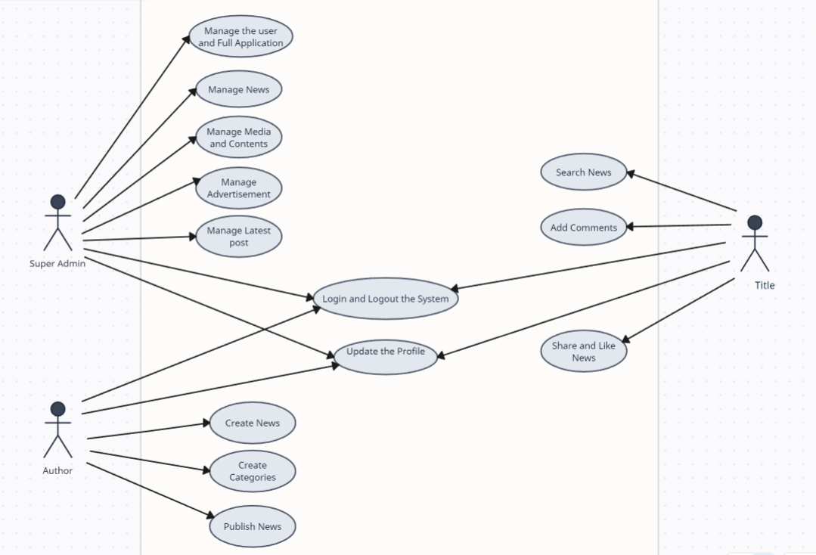

A visual representation of the interactions between the components of the News Media system is provided by this use case diagram. It stands for the approach taken during system analysis to find, make clear, and arrange the system requirements for the News Media System. In this use case diagram, the three major actors in the news media system are the super admin, the author, and the user. These three actors carry out many types of use cases, including managing news, types, contents, media, advertisements, latest posts, users, and full news portal system operations.

**2.2 Product Function**

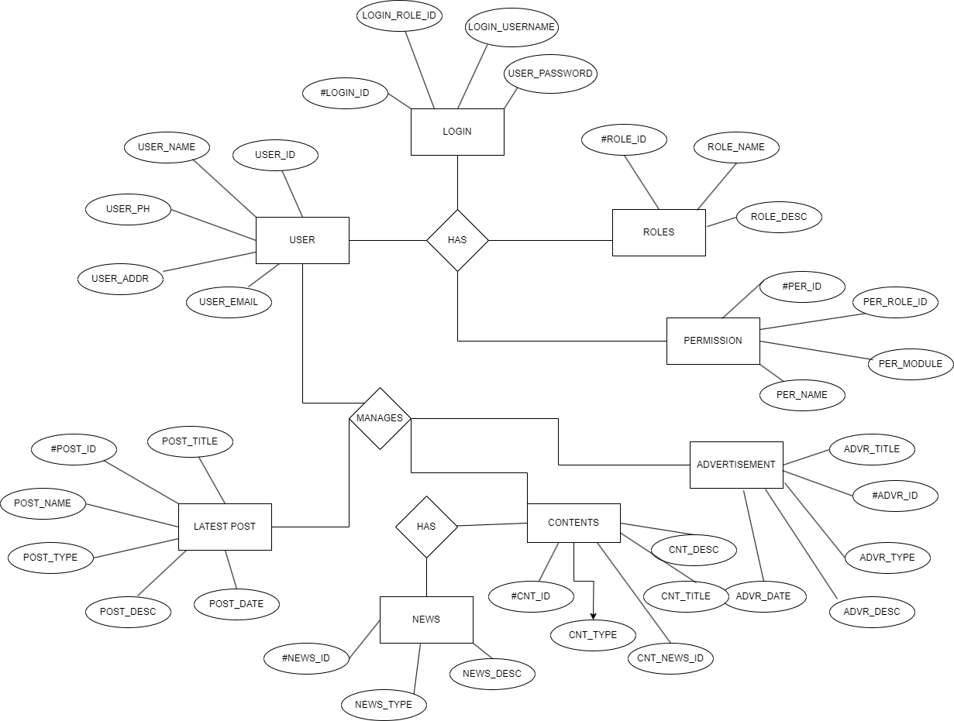

A news media application's functional purpose is to offer users a comprehensive platform for accessing, engaging with, and staying informed about news and media content. It aggregates content from diverse sources, ensuring an array of up-to-date information, and presents it in an organized, user-friendly manner. Users can personalize their experience through account creation and secure login. They can easily search for specific topics, interact with content through comments and social sharing, and receive real-time notifications for breaking news. The application leverages analytics to enhance content recommendations and incorporates advertising for monetization. It also upholds data security, accessibility, and compliance while encouraging user contributions and feedback.

**2.3 User Classes and Characteristics**

In the use case diagram you described for the News Media System, there are three main actors: Super Admin, Author, and User. The features that are available to the Super Admin are :

* Typically an administrator or system manager with the highest level of access and control.
* Responsible for overseeing and managing the entire News Media System.
* Has the authority to perform administrative tasks and configure system settings.
* Manages news, including creating, editing, and deleting news articles.
* Manages types (categories) of news articles.
* Manages content, such as text and multimedia elements within news articles.
* Manages advertisements within the system.
* Oversees and manages the latest posts or featured content.
* Manages user accounts and their permissions.
* Performs full system operations, such as backups, maintenance, and upgrades.

The features that are available to the Author are :

* Individuals responsible for creating and contributing news articles to the system.
* May have varying levels of access and permissions, depending on their role and seniority.
* Creates news articles.
* Edits and updates their own news articles.
* May be able to categorize news articles.
* Adds content, including text and media, to news articles.
* Collaborates with other authors or stakeholders in the news creation process.

The features that are available to the User are :

* Represents the general audience and readers of the News Media System.
* Users may vary in terms of their interests, preferences, and engagement levels with the platform.
* Reads and views news articles.
* Navigates and searches for articles by category or topic.
* Interacts with content, such as liking, sharing, and commenting (if these features are available).
* May create a user account for personalized features (e.g., saving favorite articles or subscriptions).
* Accesses the full news portal for general browsing and information consumption.

**2.4 Operating Environment**

The Application will be operating in a windows environment. TheNews Media Application is a website and shall operate in all famous browsers, for a model we are taking Microsoft InternetExplorer,Google Chrome,and Mozilla Firefox.Also it will be compatible with IE 6.0. Most of the features will be compatible with the Mozilla Firefox & Opera 7.0 or higher version.The only requirement to use this online application would be the internet connection.The hardware configuration include Hard Disk: 256 GB, Monitor : 15” Color monitor, Keyboard :122 keys. The basic input devices required are keyboard, mouse and output devices are monitor,printer etc.

**2.5 Assumptions and Dependencies**

The assumptions are :-

* The coding should be error free.
* The system should be user-friendly so that it is easy to use for the users.
* The information of all News posts must be stored in a database that is accessible by the website.
* The system should have more storage capacity and provide fast access to the database.
* The system should provide a search facility and support quick transactions.
* The News Media Application is running 24 hours a day.
* Users may access from any computer that has Internet browsing capabilities and an Internet connection.
* Users must have their correct usernames and passwords to enter into their online accounts
* and do actions.

The dependencies are :-

* The specific hardware and software due to which the product will be run.
* On the basis of listing requirements and specification the project will be developed and run.
* The end users (admin) should have proper understanding of the Application.
* The system should have the general report stored.
* The information of all the users must be stored in a database that is accessible by the News Media Application.
* Any update regarding the News post is to be recorded to the database and the data entered should be correct.

**2.6 Requirement**

**Software Configuration Requirements:**

- Minimum Supported Operating Systems:

-Windows: Windows 10 or later (64-bit)

-macOS: macOS 10.15 (Catalina) or later

-iOS: iOS 12 or later

-Android: Android 8.0 (Oreo) or later

- Web Browser Compatibility:

- Chrome, Firefox, Safari, and Edge, with the latest stable versions.

- Software Dependencies:

- Node.js for server-side JavaScript (recommended version: LTS).

- A modern web framework like React or Angular for web-based interfaces.

- Server-Side Software Stack:

- Database Management System: PostgreSQL 13 or MySQL 8.

- Web Server: Nginx or Apache.

- Programming Languages: Node.js (Express.js), Python (for data processing), PHP (if needed).

**Hardware Configuration Requirements:**

- Client Devices:

- Minimum RAM: 2 GB (for responsive performance)

- Minimum Storage: 32 GB of available storage (for caching and app data)

- Display: HD resolution or higher

- Server Hardware:

- CPU: Quad-core Intel Xeon or equivalent

- RAM: 16 GB (for small to medium-scale applications)

- Storage: 256 GB SSD (for OS and application)

- Network: Gigabit Ethernet

- Redundancy: Consider RAID configurations and backup systems for data resilience.

**2.7 Data Requirement**

To create a news media app it is important to have data requirements. These include storing articles, multimedia content and user generated data in an organized database. It is also crucial to integrate news sources, implement measures to protect data security, regularly backup the system and track user behavior through analytics. By doing so we can improve the performance and user experience of the application while ensuring compliance with data protection regulations. Additionally optimizing content distribution will further enhance the apps functionality while also considering user privacy and legal aspects.

**3. External Interface Requirement**

**3.1 GUI**

Designing a graphic interface for a news media system involves creating a user-friendly, visually appealing, and functional interface that allows users to access and interact with news content effectively. Here are some key components and design considerations for the graphic interface of a news media system:

Homepage Layout:

- The homepage should feature the latest news articles, videos, and other media content.

- Use a grid or card-based layout to display headlines, featured stories, and trending topics.

- Include visually engaging images or thumbnails for each news item.

Navigation Menu:

- Implement a clear and intuitive navigation menu that categorizes news content by topics

- Use easily recognizable icons or text labels for menu items.

Search and Filtering:

- Robust search functionality allowing users to search for specific news topics or keywords.

- Filters to refine search results by date, category, location, and more.

Article Pages:

- Design a readable layout for news articles with well-structured text, images, and videos.

- Include social sharing buttons to encourage users to share articles on social media platforms.

Multimedia Integration:

- Ensures seamless integration of images, videos, and audio within articles.

- Implement a responsive media player for video and audio content.

User Profiles, Authentication and Authorization:

- Users should be able to register, log in, and manage their profiles.

- User roles (e.g., reader, editor, administrator) and access permissions should be defined.

- Design user profiles that display user information, preferences, and activity history.

- Include options for users to customize their profiles and notification settings.

Comments and Interactions:

- Provide a user-friendly commenting system that allows readers to engage in discussions.

- Include upvoting/downvoting and flagging options for comments.

- Implement user avatars and timestamps for comments.

Related Articles:

- Suggest related articles at the end of news stories to keep users engaged.

- Use thumbnails and brief descriptions for related content.

Notifications:

- Design a notification center or pop-up notifications for breaking news alerts and personalized updates.

- Allow users to manage their notification preferences.

Ad Placement:

- Strategically place ads within the interface while maintaining a balance between user experience and monetization goals.

- Ensure that ads are clearly marked and do not disrupt the reading experience.

Social Media Sharing:

- Integration with social media platforms for users to share articles and content.

- Social media login options for easier user registration and sharing.

Localization and Internationalization:

- Support for multiple languages and regions to cater to a global audience.

- Content translation and localization for news articles and app interface.

**4. System Features**

The user of the system should be able to access all the news contents and feed. These resources must be trustable and prohibit the publication of fake news.This is possible by providing:

- Content Aggregation: Collect news articles, videos, and multimedia content from various sources.

- User Authentication: Allow users to create accounts, log in, and manage their profiles.

- Data Security: Implement encryption and user data protection measures.

- Legal Compliance: Adhere to copyright, privacy, and data protection laws.

- Data Backups: Regularly back up data for disaster recovery.

- Feedback and Reporting: Allow users to provide feedback and report issues.

- Comments and Interactions: Enable users to comment on articles, like, and share content.

- Personalization: Offer personalized content recommendations based on user preferences.

- Analytics and Reporting: Track user engagement and generate insights.

**5. Other Non-functional Requirements:**

**5.1 Performance Requirement:**

**Performance Objective:**

The News Media Application shall ensure responsive performance and timely delivery of news content to users.

**Performance Criteria:**

1. Page Load Time: The average page load time for news articles and the home page shall not exceed 2 seconds.

2. Scalability: The application must handle a minimum of 10,000 simultaneous users without a significant drop in performance.

3. Content Delivery: Multimedia content (e.g., images and videos) should load smoothly without buffering.

4. Caching: Implement caching mechanisms to reduce server load and decrease load times.

5. Error Handling: Error pages should be generated and displayed within 5 seconds if an issue occurs.

**5.2 Safety Requirement:**

**Safety Objective:**

The News Media Application shall prioritize user safety by ensuring that content does not pose harm or risk to users.

**Safety Measures:**

1. Content Moderation: Implement a content moderation system to filter out harmful or offensive content.

2. Report Mechanism: Provide users with a simple way to report inappropriate content.

3. User Authentication: Ensure secure user authentication to prevent unauthorized access or misuse.

**5.3 Security Requirement:**

**Security Objective:**

The News Media Application shall maintain the confidentiality, integrity, and availability of user data and protect against common security threats.

**Security Measures:**

1. Data Encryption: Implement end-to-end encryption to protect user data, especially during transmission.

2. Authentication and Authorization: Enforce user authentication and role-based access control.

3. Regular Security Audits: Conduct regular security audits and penetration testing.

4. Secure APIs: Ensure that APIs used for content delivery and user interactions are secured against common attacks.

5. Data Backup: Regularly backup user data to prevent data loss in case of system failures.

**5.4 Requirement Attributes:**

**Requirement Attributes:**

1. Priority:All requirements are considered high priority.

2. Status: Requirements will be continuously reviewed and updated throughout the project.

3. Traceability: Each requirement will be traced to specific features and components in the system design and implementation.

4. Dependencies: Identify any dependencies between requirements and components.

5. Version Control: Maintain a version control system for documentation and code changes.

**5.5 Business Rules:**

**Business Rules:**

1. Content Sources: The application will only source news content from reputable and verified news sources.

2. Ad Placement: Advertisements shall be displayed in accordance with industry standards and should not interfere with the user experience.

3. Subscription Model: Implement a subscription model for premium content access.

4. User Data: User data shall not be shared with third parties without user consent.

**5.6 User Requirements:**

**User Requirements:**

1. User Profiles: Users can create profiles with personalized preferences.

2. Search Functionality: Users can search for news articles based on keywords and categories.

3. Bookmarking: Users can bookmark and save articles for later reading.

4. Notifications: Users can subscribe to receive notifications for specific topics or breaking news.

5. Feedback: Users can provide feedback on articles and report issues with the application.

**6. Other Requirements**

**6.1 Data and Category Requirement:**

Data Requirements:

1. User Data:

- User profiles, including usernames, email addresses, and profile pictures.

- User preferences and settings, such as notification preferences and language preferences.

- User-generated data, including comments, likes, and saved articles.

2. News Content Data:

- News articles, including text, images, videos, and metadata (e.g., publication date, author).

- Categorized news content with tags, topics, and categories.

- Related content associations for suggesting similar articles.

3. Multimedia Data:

- Storage and retrieval of multimedia content, including images and videos.

- Support for various media formats and resolutions.

4. Analytics Data:

- User behavior data for analytics, including page views, click-through rates, and engagement metrics.

- Data for generating insights and recommendations.

Category Requirements:

1. News Categories:

- Define a structured categorization of news content, such as politics, technology, sports, entertainment, etc.

- Allow dynamic addition or modification of categories.

- Assign articles to one or more categories for better content organization.

2. Tagging and Keywords:

- Implement tagging and keyword features to enhance content discoverability.

- Allow authors to add relevant tags to articles.

- Enable users to search for articles based on keywords and tags.

3. Content Filtering:

- Develop content filtering options to refine search results.

- Filters can include date range, source, category, and user ratings.

4. Content Moderation:

- Implement content moderation tools to ensure compliance with platform guidelines.

- Moderators should have the ability to review and approve/reject user-generated content.

**6.2 Appendix:**

The appendix section will contain additional information and supplementary materials related to the News Media Application, including:

- Use case diagrams

- Entity-relationship diagrams

- Mockups and wireframes of the user interface

- Flowcharts illustrating system processes

- Sample data sets for testing and development

- Technical documentation for APIs and data sources

- Any other relevant materials that provide a deeper understanding of the system's architecture and functionality.

**6.3 Glossary:**

The glossary will provide definitions for technical terms, acronyms, and domain-specific terminology used throughout the software requirements specification document. It will serve as a reference for stakeholders to ensure clear communication and understanding of the document.

- API (Application Programming Interface): A set of rules and protocols that allow different software applications to communicate and interact with each other.

- CDN (Content Delivery Network): A distributed network of servers that delivers web content, such as images and videos, to users based on their geographic location, ensuring faster loading times.

- CMS (Content Management System): A software application used to create, manage, and organize digital content, including articles and multimedia.

- Data Encryption: The process of encoding data to protect it from unauthorized access or tampering, ensuring data confidentiality.

- Database Management System (DBMS): Software used to manage, store, and retrieve data from a database.

- JSON (JavaScript Object Notation): A lightweight data interchange format that is easy for humans to read and write and easy for machines to parse and generate.

- GDPR (General Data Protection Regulation): A European Union regulation that governs data protection and privacy for individuals within the EU.

- GUI (Graphical User Interface): The visual interface that allows users to interact with software applications using graphical elements, such as buttons and menus.

- HTML (Hypertext Markup Language):The standard markup language for creating web pages and web applications.

- HTTPS (Hypertext Transfer Protocol Secure): A secure version of HTTP that encrypts data exchanged between a user's browser and a website.

- IoT (Internet of Things): A network of interconnected physical devices and objects that can collect and exchange data over the internet.

- API (Internet Protocol): A set of rules governing the format of data sent over the internet.

- KPI (Key Performance Indicator): A measurable metric used to evaluate the success or performance of a system or organization.

- Multimedia: Content that includes a combination of text, images, audio, video, and interactive elements.

- MySQL: An open-source relational database management system.

- Middleware: Software that connects different software components or applications, allowing them to communicate and work together.

- Node.js: An open-source JavaScript runtime environment used for server-side programming.

- Notification: A message or alert sent to a user's device to inform them of events, such as breaking news or updates.

- Nginx: A web server and reverse proxy server used to serve web content efficiently.

- PHP: A server-side scripting language commonly used for web development.

- PostgreSQL: An open-source relational database management system.

- Push Notification: A notification that is pushed to a user's device without the user actively requesting it.

- SQL (Structured Query Language): A domain-specific language used for managing and querying relational databases.

- SSL/TLS (Secure Sockets Layer/Transport Layer Security): Protocols used to secure data transmission over the internet.

- SRS (Software Requirement Specification): A document that outlines the requirements and specifications of a software project.

- UI (User Interface): The graphical layout and elements that users interact with in a software application.

- URL (Uniform Resource Locator): A web address that specifies the location of a resource on the internet.

- User Authentication: The process of verifying the identity of a user, typically through a username and password.

- UX (User Experience): The overall experience and satisfaction of users when interacting with a software application.

- Web Browser Compatibility: Ensuring that a website or web application functions correctly and looks consistent across different web browsers.

- Web Server: Software that serves web pages and content to users' web browsers.

- Wireframe: A visual representation of a web page or application's layout and structure, often used in the design phase.

This glossary should help clarify the terminology used in the News Media Application Software Requirements Specification.